# Design Document Template

## System Overview

Provide a brief description of the purpose of the system, its target users and the environment in which the system will be used.

## References

* Provide references to other documents.
* Minimally, refer to the requirements doc.

## Environment Overview

This section should describe the environment in which the system will be run. This should include diagrams and descriptions of the environment. For example, if we are describing a web app, this will include a network diagram or topology. If we are developing a library, we should describe what might be calling us.

Be sure to address where this application will reside and how it will be executed.

## User Interface

Provide images showing how your console application will appear for every scenario of your application. Remember to include error cases.

E.g.

Initial Display:

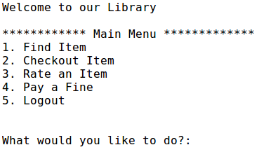

Find Item:

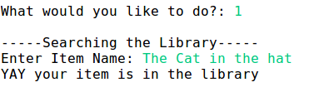

Then you will be returned back to the main menu.

….. more images would be here.

## Data Storage

Describe how you will store the data in your system. Your data will be stored as JSON files. Include a picture of how each JSON file will be formatted. Be sure to include id’s for each object, and show how the objects will be connected together via ids.

**Example.**

The data will be stored in three json files: books.json, loans.json, and users.json. Each json file holds an array of objects, and each object has a unique identifier. The loans table is the connection between books, and users. It shows which user has checked out which book. The diagram below shows how the three files are connected. You will then see a blown up version of each file.

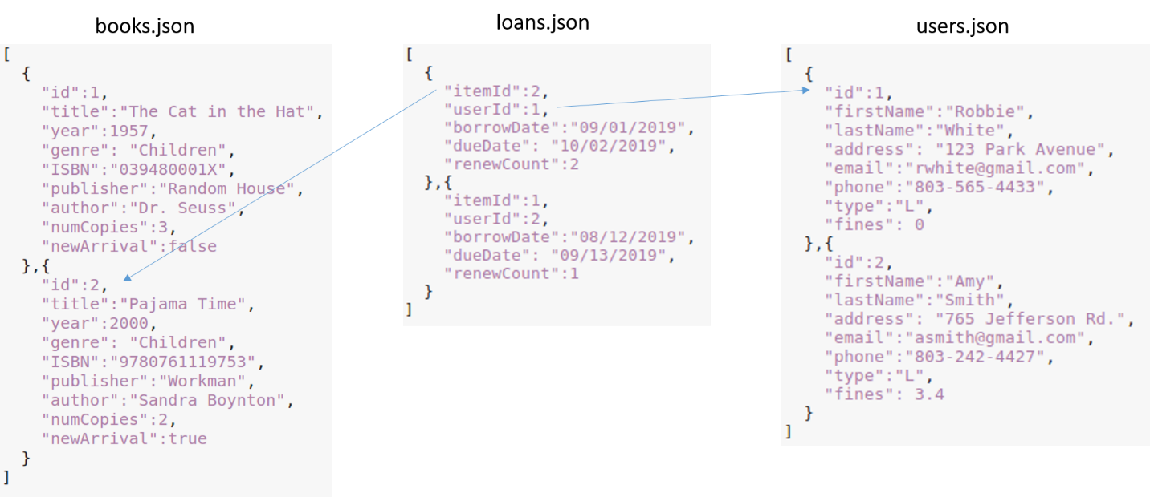

books.json:

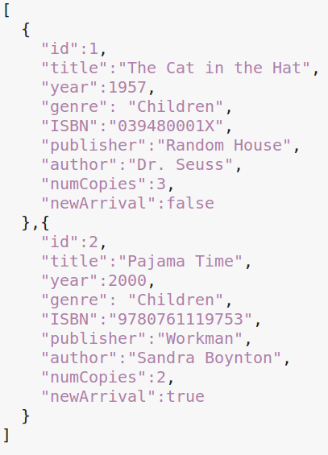

users.json:

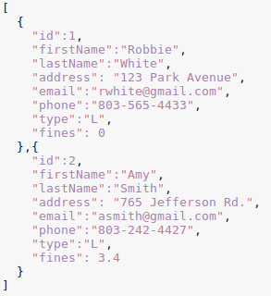

loans.json:

|  |  |
| --- | --- |
|  | Robbie White has a loan on Pajama Time  Amy Smith has a loan on TheCat in the Hat |

## Class Diagram – Structural Design

Provide a class diagram for the system. If you need to break it into smaller parts to make it easier to read, please do so. If you need to break it up, still provide a high level view where we can see how all the classes interact.

**What should go into a class diagram?**

* All the classes should find a place here.
* All associations between classes should be identified
* Associations should be decorated with the right cardinality.
* Aggregation and inheritance relationships should be identified.

Make sure you include figure numbers to help you reference figures in the document.

## Sequence Diagrams - Dynamic Model

The purpose of this section is to model how the system responds to various events, i.e., model the system’s behavior. We do this using UML sequence diagrams.

The first step is to identify different scenarios, making sure you address each use case in your requirements document. Do not invent scenarios, rather a general guideline is to include scenarios that would make sense to the customer.

## *Scenarios*

* For each scenario you will have a subsection with the following information:
* **Scenario Name:** Provide some meaningful name for the scenario (it is a good idea to include this in the subsection name.
* **Scenario Description**: A brief description of what the scenario is about and the sequence of actions that take place
* **Sequence Diagram**: A sequence diagram showing various events and their relative time ordering (as discussed in class).